Project Design Phase-II
Data Flow Diagram & User Stories
Date | 5 September 2026
Team ID / Project ID | SWUID2026190359
Project Name | Metro Ticket Generating System in ServiceNow
Maximum Marks | 4 Marks
Data Flow Diagram:A Data Flow Diagram (DFD) visually represents how information enters and leaves the system, how the information is processed, and where information is stored. This document uses a Level-0 DFD for the Metro Ticket Generating System.
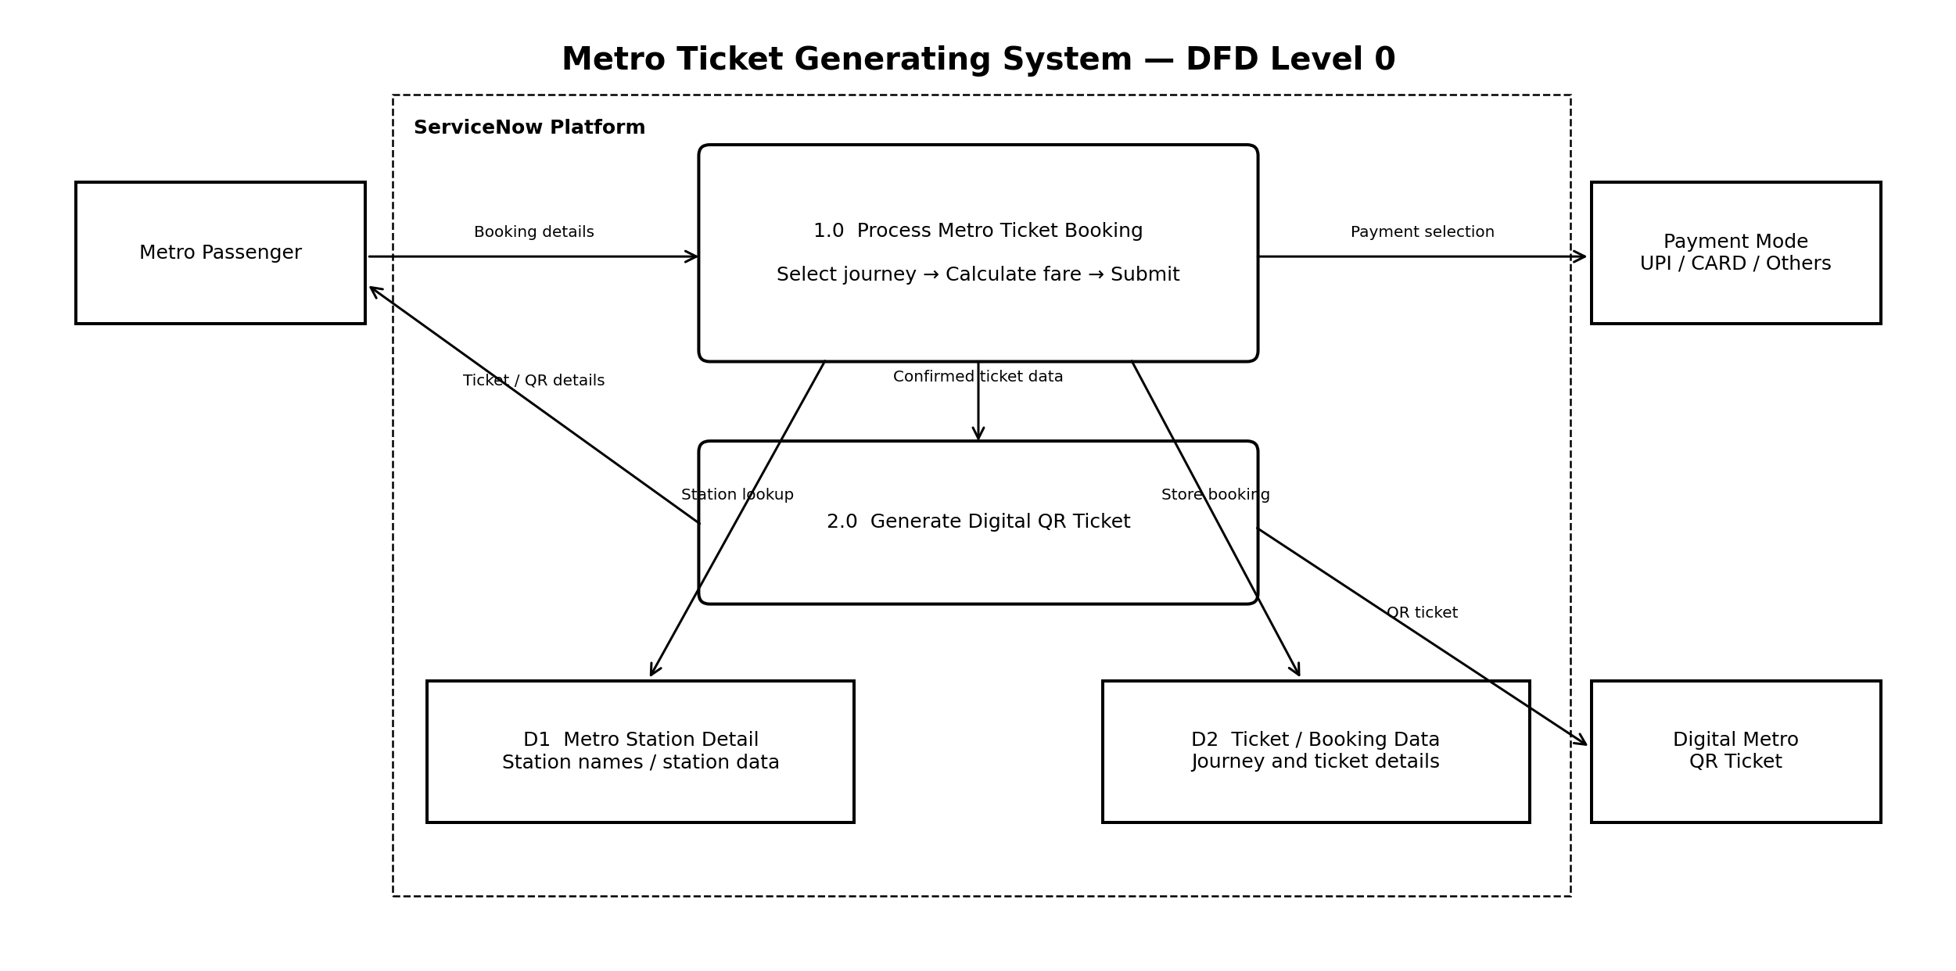
DFD Components and Data Flow
Component | Purpose
Metro Passenger | External user who provides starting station, destination, journey type, passenger count and payment mode.
1.0 Process Metro Ticket Booking | Receives booking information, validates the selections and calculates the ticket amount.
D1 Metro Station Detail | Stores metro station information used for Starting From and Going To selections.
D2 Ticket / Booking Data | Stores the journey and ticket details after the booking is processed.
2.0 Generate Digital QR Ticket | Uses the completed ticket information to generate the digital QR ticket.
Digital Metro QR Ticket | Final digital ticket provided to the passenger.

Data Flow Explanation
1. The metro passenger opens the Book A Metro Ticket catalog item in the ServiceNow Service Portal.
2. The passenger selects Starting From and Going To using the metro station details.
3. The passenger selects Single Journey or Return Journey and the number of passengers.
4. The system calculates the ticket amount automatically according to the selected route, journey type and passenger count.
5. The passenger selects UPI, CARD or Others as the payment mode.
6. The booking information is submitted and ticket details are generated.
7. The system generates the digital QR ticket, which can be used by the passenger for the journey.
User Stories
The template asks for User Type, Functional Requirement (Epic), User Story Number, User Story/Task, Acceptance Criteria, Priority and Release. The following stories are adapted to the Metro Ticket Generating System.
User Type | Functional Requirement (Epic) | User Story Number | User Story / Task | Acceptance Criteria | Priority | Release
Customer (Metro Passenger) | Metro Station Selection | USN-1 | As a user, I can select my starting metro station. | I can select a valid station from the Starting From field. | High | Sprint-1
 | Metro Station Selection | USN-2 | As a user, I can select my destination metro station. | I can select a valid station from the Going To field. | High | Sprint-1
 | Journey Details | USN-3 | As a user, I can select Single Journey or Return Journey. | The selected journey type is displayed correctly. | High | Sprint-1
 | Passenger Details | USN-4 | As a user, I can select the number of passengers. | I can select the required passenger count from the available choices. | High | Sprint-1
 | Fare Calculation | USN-5 | As a user, I can see the ticket amount calculated automatically. | The amount changes according to route, journey type and number of passengers. | High | Sprint-1
 | Payment | USN-6 | As a user, I can select UPI, CARD or Others as the payment mode. | The selected payment mode is accepted and displayed. | Medium | Sprint-1
 | Digital Ticket | USN-7 | As a user, I can view my completed metro booking details. | The ticket shows the selected journey and fare information. | High | Sprint-2
 | QR Ticket | USN-8 | As a user, I can generate a QR code for my metro ticket. | A QR code is generated and displayed for the completed ticket. | High | Sprint-2
 | Service Portal | USN-9 | As a user, I can book a metro ticket through the ServiceNow Service Portal. | The catalog item is accessible and the booking flow works correctly. | High | Sprint-2
 | Validation | USN-10 | As a user, I receive validation when required booking information is missing or invalid. | The system prevents incomplete or invalid ticket submission. | Medium | Sprint-2
 | Ticket Submission | USN-11 | As a user, I can submit my completed metro ticket request. | The request is submitted successfully with the entered details. | High | Sprint-2
 | Testing & Refinement | USN-12 | As a user, I can complete the entire ticket booking flow without incorrect ticket details. | The complete booking, fare calculation and QR generation flow works as expected. | High | Sprint-2

Architecture Summary:The system is centered on the ServiceNow Service Portal. Metro Station Detail provides station data, while the completed booking information is used to produce the digital QR ticket.

